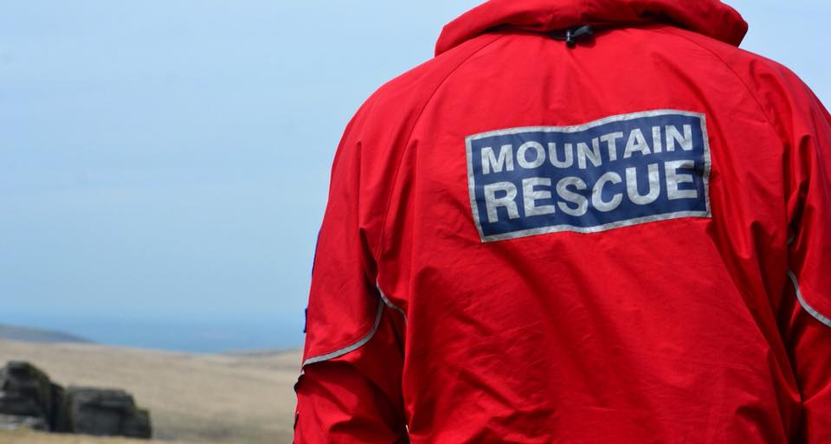

Exmoor Search & Rescue Team

Operational Team Member Application

Mountain Rescue England & Wales
Charity No: 1098037

:

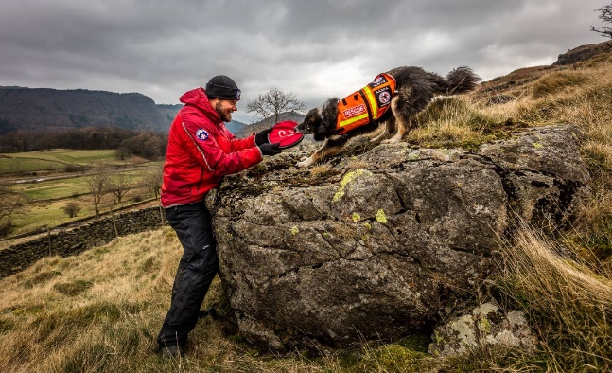
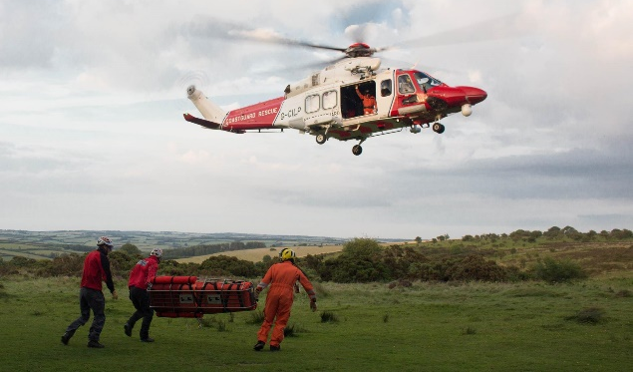

Contents

1. INTRODUCTION 3
2. PATHWAY TO FULL TEAM MEMBERSHIP 5
2.1. Initial Application 5
2.2. Prospective Trainee Induction Day/Evening 5
2.3. Probationary Period 5
2.4. Trainee Training 6
2.5. Appraisal 6
2.6. Competency Assessment 6
2.7. Operational Membership 6
3. PERSONAL DETAILS 7
4. DRIVING LICENCE DETAILS 12
5. DECLARATION OF CRIMINAL RECORD 13
Appendix 1: Personal Equipment / Kit list for Team Members 17
Appendix 2: Summary of ESRT policies 18

INTRODUCTION

Exmoor Search & Rescue Team is a voluntary Mountain Rescue Team providing specialist search and rescue services across large parts of Devon and Somerset. Our volunteer Team Members are on-call 24hrs a day, 365 days a year to assist both Avon & Somerset Police and Devon & Cornwall Police in locating lost or missing persons, and alongside South Western Ambulance Service and Devon & Somerset Fire and Rescue Service, to recover the injured and ill from remote locations.

You are applying to join a Team of highly skilled and deeply committed volunteers who all share a love of the outdoors and helping those in need – come rain or shine!

BASIC REQUIREMENTS
To apply for team membership you must:
- Be at least 18 years old.
- Have a good hillwalking background
- Be able to navigate proficiently and be able to move safely and competently over mountain/moorland terrain in all weather conditions during day and night in all seasons.
- Possess sufficient personal clothing and equipment to spend at least 24 hours working on a rescue incident.
- Be physically and mentally fit and endeavour to remain so.
- Be willing to work as part of a team, carrying out tasks as required by the leaders of the team or section.
- Be prepared to serve a probationary period. During this time applicants will be expected to attend the majority of training sessions offered by the team and will be continuously assessed on their existing hill craft skills ,newly acquired mountain rescue skills, level of fitness, temperament and suitability for team membership.
- Have a good degree of availability for attending call-outs
- Have suitable transport or other firm arrangements to attend incidents
- Be prepared to commit time and effort to ancillary jobs such as fundraising
- Appreciate the high standards of behaviour and personal integrity expected of them.

Membership of ESRT is not something to be considered lightly; despite our being unpaid volunteers, the police and public expect a professional standard of service. We are held in high regard and maintaining this reputation depends on the full commitment of its members. Joining the team will cost you time and money; you will suffer inconvenience, get wet, cold, tired and find yourself in potentially dangerous situations. Your safety and that of others will depend on your personal skills and your ability to work as part of a team.

To progress your application we will require the following information:
Personal Details
Details of Outdoor Experience and Qualifications
Details of your Driving license
Declaration of Criminal Convictions
Declaration that you have read our policies

If you have any issues with completing this form or require this form in a different format please email: membership@exmoor-srt.org.uk

FORM SUBMISSION

It is preferred that you email the completed form in pdf format to the membership secretary at:
membership@exmoor-srt.org.uk

We would prefer you insert an electronic signature where required. However, if this is not possible then by typing your name in the signature section we will take this as proof of agreement of the relevant section.

If you prefer to post your application, rather than print out the whole document please return pages 7-12 and 14-16 to:

Membership Coordinator (Confidential)
Exmoor Search & Rescue Team
Unit 4, Limefield South
Pathfields Business Park
South Molton
EX363LH

PATHWAY TO FULL TEAM MEMBERSHIP

Every trainee is expected to complete the steps outlined below to become a full team member.
Initial application to join the Team
Prospective Trainee Induction Day/Evening
Probationary Period
Trainee training
Appraisal
Competency Assessment
Operational Membership

This is a fluid process with no time frame attached. It is anticipated that everyone learns at different rates and in different ways. Some Probationary Team Members arrive with a wealth of transferable skills, while others require more time to acquire these core skills. The Team will work with you, at your own pace, to help you achieve Operational Team Member status.

Initial Application
If you feel that you fulfill the basic requirements then complete this form and email or post it to the Membership Coordinator (see previous section for details).
Your application will then be reviewed by the Team leadership and Membership Coordinator and you may be invited to attend a prospective trainee induction day (or evening). To preserve the team dynamics and to provide a positive training experience the team limit both the number of trainees and intakes during the year. Therefore you may experience a delay between application and invitation but will be informed of this.

Prospective Trainee Induction Day/Evening
The Membership Coordinator will contact you about arrangements for the day. If you are unable to attend this induction you will be invited to the following induction. This is an opportunity for you to meet some of the Team Officers, some of the Team and fellow prospective trainees. The induction is a chance for us to assess your ability to become a Team Member and for you to assess whether you wish to continue with your application. You will be expected to participate in a series of activities focusing on hill-craft, first aid, communication and leadership.

To allow an informed decision on whether you wish to continue you will be told about the set-up of the team, the trainee training programme and expectations of you as a trainee and operational team member.

Probationary Period
This period, normally 3-4 months, allows you to get to know our Trainee Team Members, the Operational Team Members, our Support Team Members, the wider Mountain Rescue Community and similarly, for the Team to become acquainted with you. The focus of your probationary period is on Team integration with a gradual introduction to training and developing your core skills. You will be assigned a mentor who will support your progress throughout your training.

Training undertaken during this period will be recorded in your training logbook.

Trainee Training
Following a formal review of your probationary period, you will be invited to continue your training, if this is something you would like to continue with.
Training is organised on a quarterly calendar, and consists of the following:
- First Thursday of the month (1930-2130hrs) - either indoor or outdoor training session together with an administrative meeting. Indoors are held at our unit at South Molton.
- Middle Wednesday (1930-2130hrs)- an outdoor training session.
- Last Sunday of each month (1000-1600hrs) - an all-day outdoor exercise/training session.
Outdoor sessions are held in a variety of locations, usually in our operational area.

The annual training diary is designed to cover the rescue skills required.
Trainees are encouraged to ask for additional training that is particularly targeted at helping complete sections of the Training logbook.

There is no prescribed time-frame or limit to the training period; Trainee Team Members are encouraged to attend core training and focus on completing the core competencies detailed within the handbook

It is important that during the training period and after it is complete you get to know all the other members of the Team. All members of ESRT will be expected to hold a ‘First aid at Work’ certificate (or Mountain First Aid). Ideally this will be obtained through the workplace, otherwise the team will fund 50% of a course after 1 year, and 100% after two years in the team.

Appraisal
Later in your training there will be an appraisal for you to inform us of how you feel you’re getting on. Your strengths and areas for development will be discussed between yourself, your mentor and members of the Team Leadership. This discussion will allow you to plan your final push to becoming a team member.

Competency Assessment
The final stage in training will be a performance review in a simulated operational exercise to check you have the core set of mountain search and rescue skills required for full team membership.

Operational Membership
When your membership has been agreed, you will be placed on our call-out list. We are on call 365 days a year 24 hours a day. Understandably there will be times when you may be unable to attend, but you will be expected to attend a minimum 60% of all organised training activities as an ongoing commitment to your continued training. You will also be required to participate on a regular basis in the cleaning and maintenance of the team’s premises, vehicles and equipment.

As a charity we have to raise all our own funds. Public relations and fund-raising events form an important part of the Team’s activities and your commitment and participation in these is also expected.

PERSONAL DETAILS

The information disclosed on this form will be treated with the strictest confidence and will only be seen by those Officers directly involved with the membership and training process, and will be stored in line with our data protection policy.

Surname: | Forename(s): |  | Date of Birth:
Address:
Postcode: |  | email:
Tel. (home): | Tel. (work): |  | Mobile:
Next of Kin
Surname: | Forename:
Contact Details:
Do you have any health problems, physical or mental, that may affect your ability to carry out all rescue duties? Please give details
We advise all full Team Members to be vaccinated against Hepatitis B

Occupation

Current position:

Previous employment which may have enhanced your services to Search and Rescue:

EXPERIENCE + QUALIFICATIONS

Navigation
You will be expected to demonstrate competency using map and compass as well as show sound skills in route finding and general hill craft before being considered for training.

Can you navigate using map and compass, accurately and on time, in adverse weather conditions, to a 6 figure grid reference?

Experience
Please provide details of the experience in the following arenas:

Area | Y/N | Experience
Hillwalking Exmoor
Hillwalking (UK) Summer
Hillwalking (UK) Winter
Hillwalking Europe
Climbing (Summer)
Climbing (Winter)
Qualifications
Please indicate qualification held and expiry date where applicable

Qualifications |  | Expiry
HML/WGL
ML (Summer)
ML (Winter)
BEL
SPA
MIC
Other

Previous Mountain/Search and Rescue experience:

Other outdoor activities (mountain biking, orienteering etc):

Describe your knowledge of the Somerset/Devon area:

Nil Minimal Average Good

First Aid/ Medical Qualifications
A basic first aid qualification is a prerequisite of membership. You are expected to obtain one within six months of acceptance of this membership application if you have not done so already.

Qualification | Expiry Date
Outdoor first aid certificate
First Aid at work
MREW Cas Care certificate
Emergency Technician Qualification
Nurse
Paramedic
Practicing doctor
Other

Availability
Please give details of any times that you would be unavailable for training or callouts:

Are there any other circumstances (e.g. employment, education etc), which could lead to you being unavailable for longer periods of time?

Are you currently a member of any other voluntary, or similar, organisation? If yes please give an indication of time commitment:

Please give details of any special requirements you may have regarding learning (large print, dyslexia, etc) which the team could facilitate to assist during training:

General

Please state briefly why you wish to become a member of the Exmoor Search and Rescue Team:

How did you hear about the Team?

References

Please give details of two people who would be willing to act as referees for you. At least one should be an employer:

Name: Name:
Occupation: Occupation:
Address: Address:

Please continue on another sheet if necessary for any section

DRIVING LICENCE DETAILS

Having a full driving licence and suitable transport to attend incidents is preferred however, applicants can still apply as long as they have other formal arrangements available.

As part of the application we need to verify the details of your driving licence. We require the use of a temporary security code to allow us to access the DVLA website as detailed below:
https://www.gov.uk/view-driving-licence
To do this you will need the following information:
Your driving licence number
Your National Insurance number
The postcode on your driving licence

Applicant Name:
I have a valid driving licence | Yes / No
Evidence of licence | DVLA Share
Security number to access details of your driving licence (case sensitive)
Last eight figures from your driving licence

Driving Convictions
For insurance purposes we require details of any current driving convictions, cautions or speed awareness courses.

Do you have any current (or pending) convictions for motoring offences, or points on your licence, or attended a speed awareness course?
 | Yes | No | Details
Current Convictions
Convictions Pending
Points
Points (expiry)
Speed Awareness (attended)
Speed Awareness (pending)

DECLARATION OF CRIMINAL RECORD
(INCLUDING FITNESS TO PRACTICE DECLARATION FOR HEALTH PROFESSIONALS)

Exmoor Search & Rescue Team (ESRT) requires all applicants to disclose certain information on any previous criminal record that they may hold. The information disclosed on the forms will be treated with the strictest confidence and will only be seen by those officers directly involved with the membership and training process.

The declaration of Criminal Record Form is available in Appendix 4.

A person’s criminal record will not, in itself, debar that person from being allowed to become a full Team Member. Suitable applicants will not be refused membership because of offences which are not relevant to, and do not place them at or make them a risk in, the role of a full Team Member.

All cases will be examined on an individual basis and will take the following into consideration:

- Whether the conviction is relevant to the position applied for
- The seriousness of any offence revealed
- The age of the applicant at the time of the offence(s)
- The length of time since the offence(s) occurred
- Whether the applicant has a pattern of offending behaviour.
- The circumstances surrounding the offence(s), and the explanation(s) offered by the person concerned
- Whether the applicant's circumstances have changed since the offending behaviour

ESRT believe that the service we provide, in the provision of medical assistance to often vulnerable persons, is exempt from the Rehabilitation of Offenders Act 1974 and therefore applicants are required to declare any convictions, cautions, reprimands and final warnings that are not protected (i.e. that are not filtered out) as defined by the Rehabilitation of Offenders Act 1974 (Exceptions) Order 1975 (as amended in 2013).

For further information on filtering please refer to the DBS website.

It is important that applicants understand that failure to disclose all convictions, cautions, reprimands or final warnings that are not protected could result in disciplinary proceedings or dismissal from the Team.

Declaration of Criminal Record
(Including Fitness to Practice declaration for Health Care Professionals)

Applicant Name ………………………………
Section A – please complete all this section (where you have answered yes to any questions please give details in the table in Section B or on a separate piece of paper).
Have you received a conviction, caution, reprimand or a warning which has been recorded on a police central record, (includes ‘spent’ and ‘unspent’ convictions) or has any information been held locally by police forces, including police enquiries undertaken following allegations made against you, but excluding parking offences, that are grounds to be considered relevant? This also includes any information that may be held on the DBS’s children and adults barred list.

Do you have any criminal convictions?  If you have ticked yes you must give full details of all your convictions whether spent or not, as listed in Section B. | YES NO
Have you ever been cautioned by the police for any reason?  If you have ticked yes you must give full details. | YES NO
Do you have any pending matters for which you are currently being investigated, for example, by the police or other enforcement agency?  If you have ticked yes you must give full details. | YES NO
Do you have any pending criminal convictions?  If you have ticked yes you must give full details. | YES NO
Do you have any convictions or pending matters in any other country?  If you have ticked yes you must give full details. | YES NO
Have you been disciplined by any organisation responsible for regulating or licensing a health or social care profession or suspended or placed under a practice restriction by an employer or similar organisation because of concerns about your conduct or competence  If you have ticked yes you must give full details. | YES NO

Declaration of Criminal Record
(Including Fitness to Practice declaration for Health Professionals)
Section B – please complete all this section.
I do solemnly and sincerely declare that (tick either declaration 1 or 2 as appropriate):
EITHER
1 | I do not have any convictions or cautions to declare and I am not subject to any pending prosecutions or being investigated for any other matter.
OR
2 | I list here full details of all convictions and cautions I have ever received. I also list full details of any offences for which I am currently being prosecuted or other matter for which I am being investigated.

Convictions, Cautions and Pending Criminal Prosecutions Details
(EXCLUDING Motoring)
Date Convicted | Type of Conviction  (Criminal, Caution or Pending Matter | Court or Police | Offence or Pending Matter | Penalty
If necessary, please continue on a blank sheet of paper

DECLARATION
I declare that the information I have provided in relation to criminal convictions, prosecutions pending and cautions is accurate. I understand that the declaration of a criminal record will not necessarily prevent me from being offered membership of Exmoor Search & Rescue Team.

I agree that further enquiries that are considered necessary may be undertaken, including a full Disclosure Barring Service check (formerly CRB Criminal Record Bureau).

NAME (please print) …………………………………………..

Signature …………………………….. Date……………..

GENERAL DISCLAIMER

Exmoor Search and Rescue Team

Applicant Name ………………………………
I agree to the following:
- I wish to be considered for membership of Exmoor Search & Rescue Team.

- I have read, understood and agree to abide by the information given/ referred to in the application pack, (including Health and Safety, Risk Assessment, Equality, and CRB policies).

- That the information provided in this form is true and accurate. Falsification may lead to any subsequent offers of membership being withdrawn.

- That Exmoor Search & Rescue Team may process my personal information provided in this form and if applicable during the course of my membership, in line with current data protection legislation. Furtermore, I understand that my details will not be passed to organisations for marketing or sales purposes

- That I will at all times abide by the Team's governing documents and its rules and procedures.

- Whilst wearing Team kit, I will act in a manner suitable for a member of a Mountain Rescue Team.

- I will not purport to represent the Team, or use the Team’s name in any connection, or act on its behalf without the authority of the Team Leadership / executive committee.

- I recognise that there may be occasions when the work may involve an element of danger to participants.

- I agree/do not agree* to my photograph being held on the data bank maintained by the Exmoor Search and Rescue Team.

- I do/do not* agree to my image being used on the web site of the Exmoor Search and Rescue Team and used in other publications or displays to illustrate the work of the Team.

*delete as appropriate

Signed...................................................... Date …………….

Appendix 1: Personal Equipment / Kit list for Team Members

All operational team members must have sufficient clothing that is fit for purpose and consistent with our role to survive in any weather conditions for up to a 24hr deployment.
What form this takes is a matter for the individual member, but everyone must at all times remain readily recognisable and professional in appearance.
Below is a suggested kit list to fulfil these requirements

Suggested kit list for Trainees

Base layer (wicking; preferably not cotton)
Mid layer/s (e.g. fleece top / jacket)
Trousers (quick drying; not jeans)
Wind and waterproof jacket
Waterproof over-trousers
Boots
Socks
Hat (warm / sun as appropriate)
Gloves

Map
Compass
Whistle
Rucksack of at least 40 litres (40-50 litre capacity is recommended)

Trainees are expected to have a certain amount of suitable kit. Trainees need not attempt to purchase the entire requirement of kit until being accepted as a full team member. There are also opportunities to acquire / get discounts on kit as a trainee / team member with various outdoor firms. Please ask about the opportunities.

Team Members to wear or carry – all year round

Team issue waterproof jacket and / or belay jacket (depending on forecast conditions)
Team issue base layer
Team issue mid layer (depending on conditions)
Team issue helmet
Team issue torch (available for use when required)
Team issue hi-viz jacket (carried at all times)
Rucksack of at least 40 litres (40-50 litre capacity is recommended)
Map
Compass
Whistle
Notebook and pen
Personal first aid kit (in case separated from search party; except for cas carer carrying kit)
Small group shelter or survival bag
Blizzard bag and / or insulated jacket in winter

Appendix 2: Summary of ESRT policies

The key policies which outline expectations of behaviours from both the team and trainees are summarised below. Full details of these policies are available, to successful applicants, via our online data repository.

Health and safety/ Risk Assessment statement
Mountain Rescue can be a strenuous, sometimes hazardous activity, frequently carried out under difficult conditions. Team Members have a duty of care to the casualty and their fellow Team Members. It remains the responsibility of every Trainee, Member, or Support Team Member to safe guard to the best of their ability, the welfare of, and prevention of, physical, sexual or emotional abuse of all children, elderly, disabled or otherwise vulnerable persons, with whom they come into contact, during their duties associated with the Team.

To minimise potentially dangerous situations you should tell the Team Leader or Medical Officer of any medical problems that could interfere with your performance during a Mountain Rescue activity. Should a medical problem develop during your membership you should inform the Team Leader or Medical Officer immediately. They may restrict you from performing certain Mountain Rescue activities based on this information. If you have any doubts about your ability you are urged to seriously reconsider your application.

It is the responsibility of all volunteers to abide by regulations and procedures laid down for their health and safety. It is a condition of membership that they take reasonable care to safeguard their health and safety and that of other persons who may be affected by their actions. Volunteers who are aware of any condition, which may be dangerous or unsatisfactory, are to bring the matter to the attention of the Team Leader or the Executive Committee.

All injuries, however slight, must be reported to the Team Leader, Welfare Officer, or Training Officer, and must be entered in the accident book as soon as possible. Team risk assessments are available on the team’s online repository (paper copies on request) and are regularly reviewed and updated. Everyone involved with the Team should make themselves familiar with their content.

Equality / Recruitment of ex-criminals
ESRT are committed to providing equal opportunities to our membership (hill going, trainees, Support Team, trustees) and partners in an inclusive way, workers and service users, and to encouraging diversity.
We do not tolerate any unlawful or unfair discrimination and anyone found to be acting in a discriminatory manner will face disciplinary action which could include dismissal. Everyone has a duty to report unlawful or unfair discriminatory behaviour to a member of management. We actively promote equality of opportunity and require everyone to contribute towards achieving this objective.
We believe that treating people with dignity and respect is an important part of realising equal opportunities and diversity, and this policy should be read in conjunction with our harassment and bullying policy.

It is essential that all members of the Team behave with dignity, courtesy and respect and to act in a non-discriminatory manner at all times.
Data Protection and Safe storage policies
Exmoor Search & Rescue Team has a responsibility to ensure your personal information that we store is kept safe and secure. This policy details how, when and why we store and use your personal data and adhere to the new GDPR.

This statement sets out the basis on which such information is held. We may make changes to this statement from time to time to reflect developments in the law.

The following data is stored by the team:
• Contact Details: Name; address, email, telephone numbers
• Next of kin
• Occupation
• Outdoor experience and qualifications (pertinent to mountain rescue)
• Any fitness/medical condition that would have a bearing on mountain rescue activities
• Details of driving licence
• Any criminal record (including driving convictions)
• Record of attendance and training
• Record of equipment issued
• Sort Code / Account Number –for repayment of expenses

Your information is held securely with the membership officer, medical officer and/or treasurer primarily in electronic format on password protected computers. No sensitive data can be held by team members. Records of attendance may also be held by relevant officers.

How we use this data
We use this data internally to manage your application, training and membership to the team. It allows us to:
• Communicate – general team information, call-outs
• Record initial training and ongoing professional development
• Record equipment issued including sizes for inventory and future purchases
We can also use this data externally with third parties. This allows us to:
• Make and process payments – through our bank
• Carry out regulatory requirements – HM Revenue and Customs, insurance declarations
• Bookings on courses
Our promise to you
• We will always tell you what information we hold and how it is used
• We will always keep your data safe and private
• We will not sell your data
• We will not pass your data to third parties unless directly related to mountain rescue activities (eg Police, Coroner or Mountain Rescue England & Wales)
• We will give you ways to manage and update your account data and preferences
• We will not keep this data for longer than necessary for its purpose

By consenting to our Data Protection Privacy notice you are giving permission for Exmoor SRT to process your personal data specifically for the purposes identified. You may request to see this information, correct it and withdraw consent at any time.

Child and Vulnerable Adult Protection Policy

Exmoor Search & Rescue Team (ESRT) makes a positive contribution to a strong and safe community and recognises the right of every individual to stay safe. ESRT does not accept anyone under the age of eighteen in any class of membership (team, trainee, and supporter). However the team may expect to have dealings with children and vulnerable adults both during its operational activities and through talks and demonstrations given to such groups. Furthermore, in an operational context some of the recipients of our services could be said to be vulnerable because they may need medical care or transportation to a place where they receive medical care and would therefore be considered vulnerable at that time.
ESRT has a professional duty to provide children and vulnerable adults with appropriate safety and protection and expects team members to protect the professional integrity of themselves and the organisation. All ESRT members (hill team, trainee, supporter) have a responsibility to follow the guidance laid out in the policy, and to pass on any welfare concerns using the required procedures. We expect all members to promote good practice by being an excellent role model, contribute to discussions about safeguarding and to positively involve people in developing safe practices.
In aiming to achieve these standards, ESRT requires that when dealing with children and vulnerable adults, and regardless of their gender, ethnicity, disability, sexuality or beliefs, its members will:
- Accept responsibility for their protection and treat their welfare and well-being as paramount.
- Treat them with dignity and respect.
- Respect personal privacy (including no photography/video without permission of a responsible adult).
- Be sensitive to their needs.
- Avoid any unnecessary physical contact. If this is unavoidable ensure another adult is present or within sight or hearing distance.
- Avoid questionable activity e.g. rough or sexually provocative behaviour and inappropriate language.
- Wherever possible avoid one-to-one situations or running events single-handed.
- Challenge all unacceptable behaviour/language.
- Not tolerate bullying.
- Report immediately any allegation or suspicion of abuse to a member of the Team Leadership, Trustee or Chairman.
If the professional boundaries and/or policies are breached this could result in disciplinary procedures or enactment of the allegation management procedures.
In achieving our policy aims and being proactive, we have developed procedures related to the recruitment of Team Members and how allegations of child/vulnerable adult abuse should be dealt with. In light of this, we implement safe recruitment practices in checking the suitability of team members to work with children and vulnerable adults.

Allegations of abuse will be taken seriously and dealt with as soon as practicable, in line with the recognised Child/Vulnerable Adult Protection Policy. The Executive Committee is also responsible for conducting any investigation and demonstrating the results if the child/vulnerable abuse is suspected to be committed by a member of the Team. Throughout this procedure, records will be maintained and kept securely and confidentially, separately from the Team member’s file.
DBS Records Check / Police vetting

Exmoor Search and Rescue Team is a recognised Police resource, therefore it is imperative that persons who are invited to join, wear the badge, and represent the Team are; recognised as being responsible members of the public, capable of upholding the law and protecting vulnerable persons.

The Team may request permission to carry out a Disclosure and Barring Services (DBS) check on you should they deem this necessary. This would not identify ‘minor’ or ‘traffic offences’ but would state whether you have been successfully prosecuted for sexual or violent crimes. The Executive Committee will not be informed of the specifics of any prosecution and any information given will be treated confidentially. Prior to becoming a full Team Member you may be required to go through Police vetting.

Information regarding the Teams’ policies on the recruitment of ex criminals, data protection and safe storage of data, and disclosures are all available upon request.

Applicants are required to complete this application form (which may lead to a subsequent induction) which contains explicit information about their past. These are required to be returned to the Membership Coordinator who manages the recruitment process.

End of Document

